Step 1 – PCA
Code outline:
from sklearn.preprocessing import StandardScaler
from sklearn.decomposition import PCA
import pandas as pd
import matplotlib.pyplot as plt

df = pd.DataFrame({
"Hours": [2,3,6,7,8],
"Attendance": [40,55,75,85,95],
"Quiz": [50,60,72,88,92],
"Result": ["Fail","Fail","Pass","Pass","Pass"]
})

X = df[["Hours", "Attendance", "Quiz"]]
X_scaled = StandardScaler().fit_transform(X)

pca = PCA(n_components=2)
X_pca = pca.fit_transform(X_scaled)

print("Explained Variance Ratios:", pca.explained_variance_ratio_)
print("PCA Components:\n", pca.components_)

plt.figure(figsize=(5,4))
plt.scatter(X_pca[:,0], X_pca[:,1], c=(df["Result"]=="Pass").map({True:"blue",False:"red"}))
for i, txt in enumerate(df.index):
plt.text(X_pca[i,0]+0.05, X_pca[i,1]+0.05, f"S{i}")
plt.xlabel("PC1")
plt.ylabel("PC2")
plt.title("PCA: Student Dataset")
plt.show()

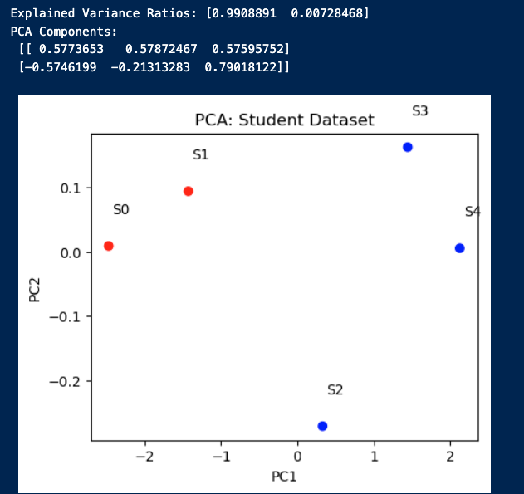

Key findings:
- PC1 roughly represents overall performance (study + attendance + quiz).
- PC2 captures smaller variation between study and attendance.
- PCA does not use class labels → separation between Pass and Fail may be partial or blurred.
- Explained variance ratio often shows PC1 capturing >90% of total variance.

Step 2 – LDA
Code outline:

from sklearn.discriminant_analysis import LinearDiscriminantAnalysis as LDA
import numpy as np

lda = LDA(n_components=1)
X_lda = lda.fit_transform(X, df["Result"])

plt.figure(figsize=(7,2.5))
plt.scatter(X_lda[df["Result"]=="Fail"], np.zeros(sum(df["Result"]=="Fail")),
color="red", label="Fail", s=100)
plt.scatter(X_lda[df["Result"]=="Pass"], np.zeros(sum(df["Result"]=="Pass")),
color="blue", label="Pass", s=100)
plt.axvline(X_lda[df["Result"]=="Fail"].mean(), color="red", linestyle="--", label="Fail mean")
plt.axvline(X_lda[df["Result"]=="Pass"].mean(), color="blue", linestyle="--", label="Pass mean")
plt.xlabel("LDA Projection (1D)")
plt.legend()
plt.title("LDA: Separation of Pass vs Fail")
plt.show()

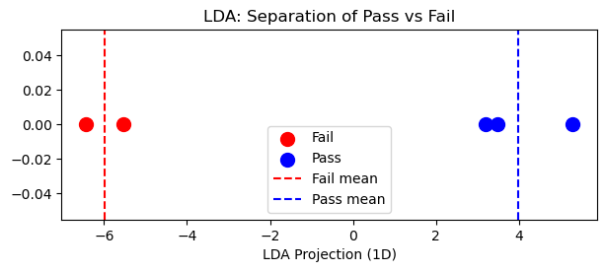
Key findings:
- LDA explicitly uses Result labels to find the best separating line.
- The projection score measures each student’s position along the discriminant axis.
- Pass and Fail are clearly separated in 1D space — a perfect example of supervised dimensionality reduction.

Step 3 – Conceptual Answers
Question | PCA | LDA
Primary goal | Find directions of maximum variance in data | Find directions that maximize class separation
Requires labels? | No | Yes
Sensitive to scaling? | Yes | Somewhat (but less critical if features are comparable)
Resulting space | Unsupervised, orthogonal components | Supervised, optimal for discrimination
Typical output | PC1, PC2 (continuous axes) | LD1 (1D discriminant line)
Scaling before PCA ensures no single feature dominates due to units (e.g., percentages vs hours).
LDA focuses on how features differ between classes, not how large they are individually.

Takeaway notes:
- PCA reveals structure in unlabeled data (useful for visualization, noise reduction).
- LDA creates a decision boundary (useful for classification and explainability).
- In this example:
  - PCA shows that “attendance” and “study hours” both vary with success,
but the boundary isn’t explicit.
  - LDA quantifies exactly how these two features combine to separate Pass vs Fail.

